Lecture 21

Process-daemons-PerformaceMonitoring-P2

**Top commands**

* How to check load like a task manager 🡪 through top command
* Others are
* htop
* Sar
* Iostat 🡪 for HDD load
* Vmstat 🡪 memory and swap load
* 🡪 iometer
* Iprf 🡪 network monitoring
* Tcpdump 🡪 network bandwidth

There are several performance monitoring tools in Linux, some of the most commonly used include:

1. top: displays real-time information about system processes and resource usage
2. htop: an interactive version of top with a user-friendly interface
3. iostat: provides statistics on I/O usage
4. vmstat: provides information on system processes, memory, paging, and block I/O
5. mpstat: provides information on processor usage
6. sar: system activity reporter, provide information on various system metrics over time
7. netstat: provides information on network connections and statistics
8. free: provides information on system memory usage

These are just a few examples of the many performance monitoring tools available for Linux. The appropriate tool to use will depend on your specific needs and the type of information you are trying to gather.

* To check the processes of RAM navigation
* Go to /proc
* $ /proc – ls 🡪 contains process files navigated from RAM
* Top explained
* These processes below are in /proc directory
* 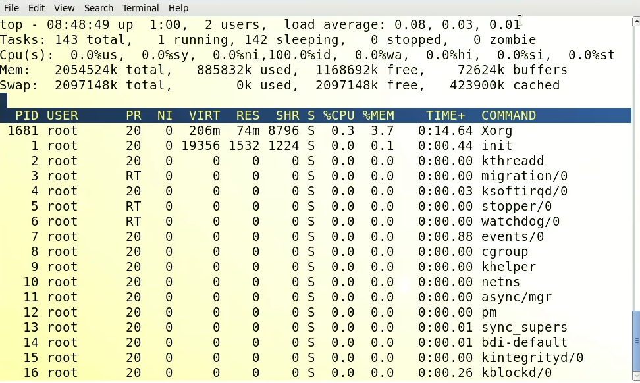
* $ cat /proc/meminfo
* **Remember:-** the application waiting in queue to be executed is called “load” , 1 application waiting = load 1, 2 applications waiting = load2 and so on
* **$ free -m 🡪 memory info, RAM**
* 